− Report View page

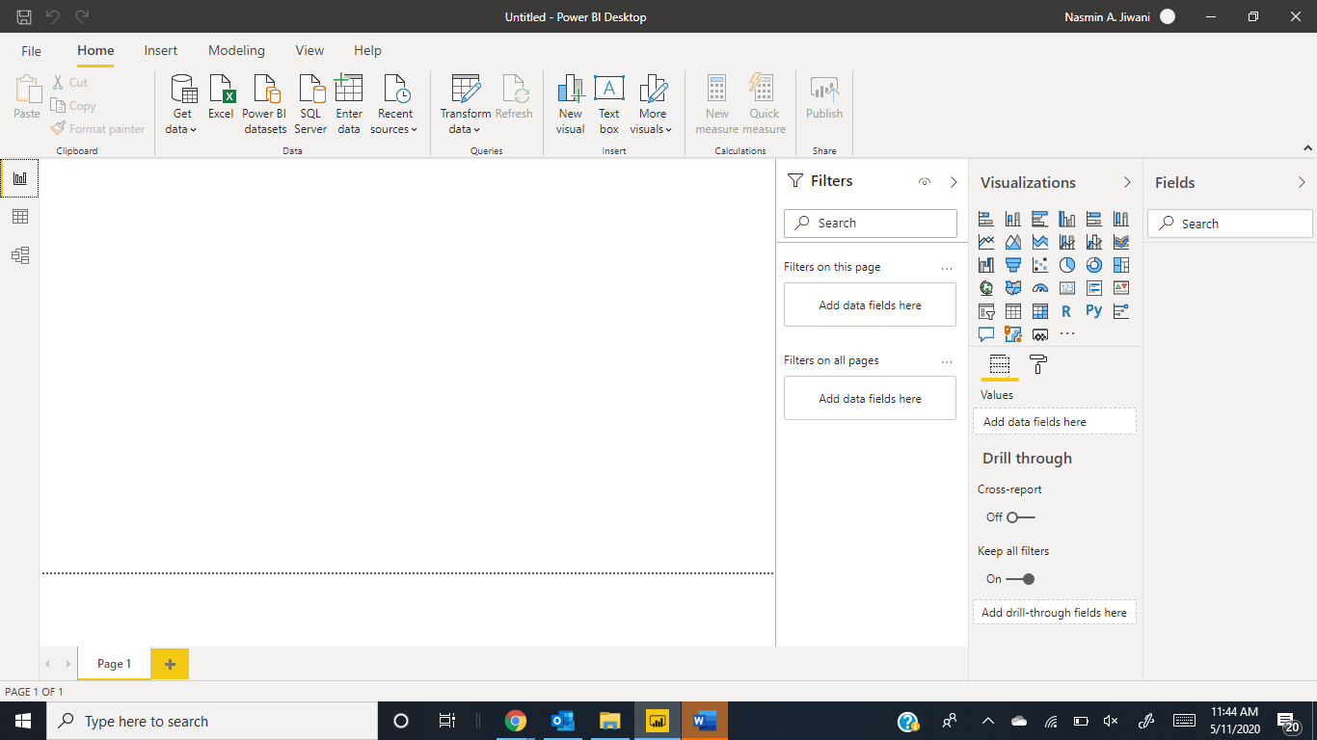

− Data View
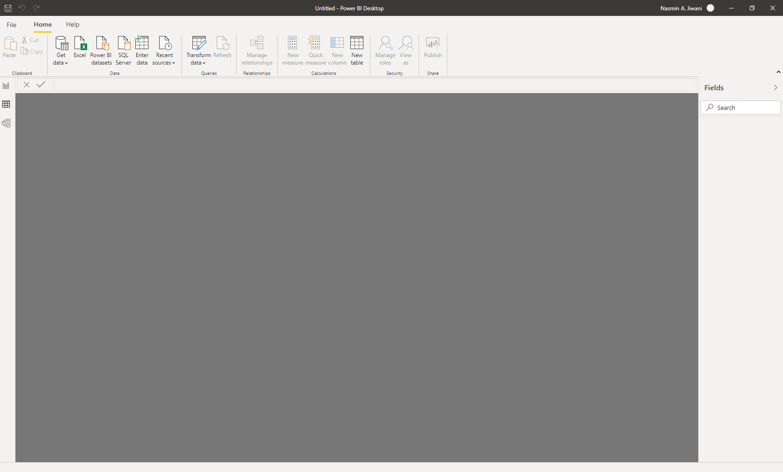

− Model View
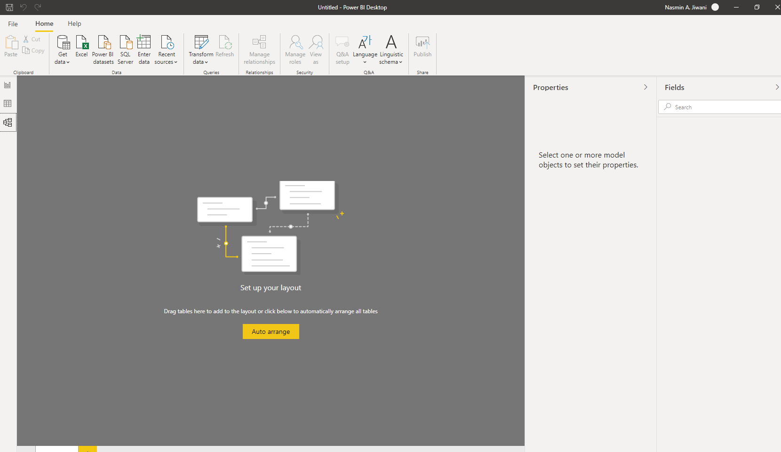
− Power Query Editor

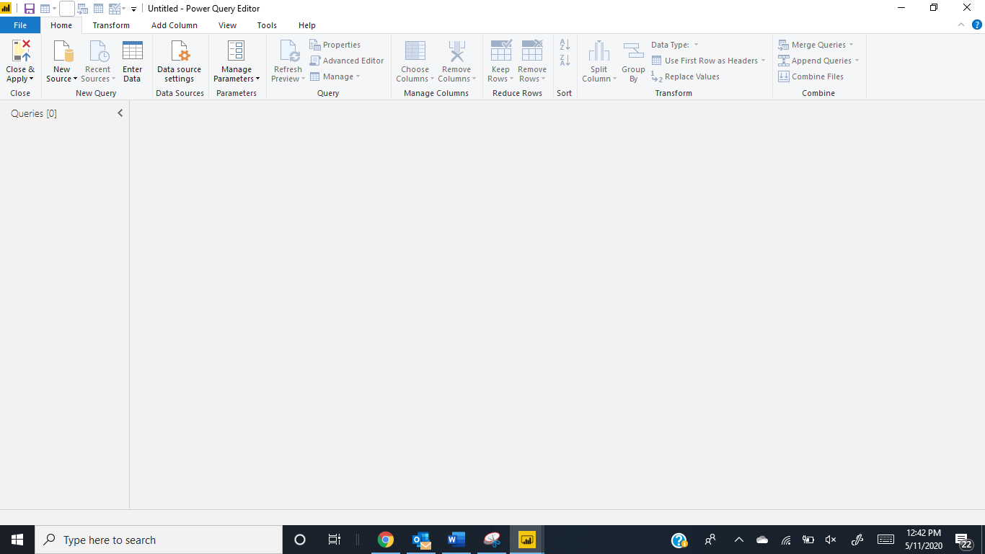
− Advance Editor

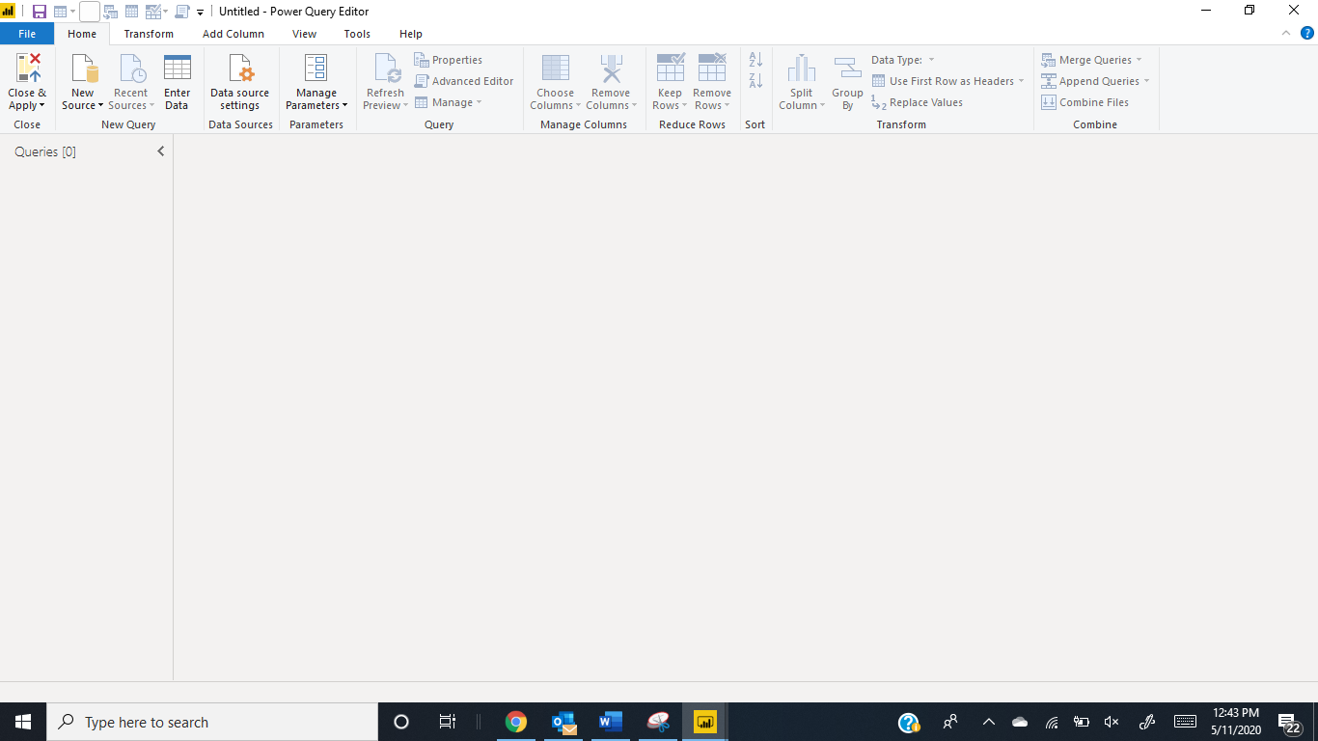

− Power BI Desktop

Power BI Desktop is a free application you install on your local computer that lets you connect to, transform, and visualize your data. ... Create visuals, such as charts or graphs, that provide visual representations of the data. Create reports that are collections of visuals, on one or more report pages.
− Power BI Pro
Power BI Pro is an individual user license that lets users read and interact with reports and dashboards that others have published to the Power BI service. Users with this license type can share content and collaborate with other Power BI Pro users. Only Power BI Pro users can publish or share content with other users or consume content that's created by others, unless a Power BI Premium capacity hosts that content.

Purchase licenses in Microsoft 365
Follow these steps to purchase Power BI Pro licenses in the Microsoft 365 admin center:
- Sign in to the Microsoft 365 admin center.
- On the navigation menu, select Billing > Purchase services.
- Search or scroll to find the subscription you want to buy. You'll find Power BI under Other categories that might interest you near the bottom of the page. Select the link to view the Power BI subscriptions available to your organization.
- Select Power BI Pro.
- On the Purchase services page, select Buy.
- Choose Pay monthly or Pay for a full year, according to how you want to pay.
- Under How many users do you want? enter the number of licenses to buy, then select Check out now to complete the transaction.
- To verify your purchase, go to Billing > Products & services and look for Power BI Pro.
- To add more licenses later, locate Power BI Pro on the Products & services page, and then select Add/Remove licenses.

− Power BI Premium

Power BI Premium consists of capacity in the Power BI service exclusively allocated to each organization. The capacity is supported by dedicated hardware fully managed by Microsoft. Organizations can choose to apply their dedicated capacity broadly, or allocate it to assigned workspaces based on the number of users, workload needs, or other factors—and scale up or down as requirements change.

How is Power BI Pro different than Power BI Premium?
Power BI Premium is a capacity-based license, while Power BI Pro is a user-based license. Power BI Pro is for those users publishing reports, sharing dashboards, collaborating with colleagues in workspaces and engaging in other related activities – such as the ability to:
- Edit and save customized views
- Create personal dashboards (pin to new dashboard)
- Analyze data in Excel or Power BI Desktop
- Share with Excel Web App support
- Share dashboards and collaborate with Office 365 Groups
- Integrate content with Microsoft Teams

